**1. Introduction**

In this report, we will apply the techniques and algorithm learnt in these years of study, so as to solve some prevalent statistical computing problems by applying root finding algorithms, optimization algorithms, numerical integration and resampling algorithms.

**2. Root Finding Algorithm(Q1)**

**Find the maximal value of $\frac{\log\left(x+x^{2}\right)}{1+x^{3}}$, where x>0**

In order to find the maximal value of a function, we need 2 steps:

**Step1:** find the root of first derivative of the function

**Step2:** substitute the root in the original function.

In order to know what the behavior of the function is, we usually get a rough idea of the function by plotting a graph. $Please refer to 1.1 and 1.2 in appendix.$

From 1.1, we found that the maximum value should between 0 and 1, around 0.5. From the 2.2, we can find that the root of first derivative of the function is between 1 and 2, and very close to 1. Therefore, we can easily find the endpoints of the bisection and first guess of Newton-Raphson method more easily in the following.

**2.1 Bisection method**

Assume $f(x)$ is continuous on $[a, b]$ on $R^{1}$. By Intermediate value theorem, if there is a number (called $c$) such that $f(a)<c<f(b)$, then there must exist some x between a and b such that $f(x)=c$.

We would like to find roots of the first derivative of the function in this time. Therefore, c equals to 0 this time. It also means that $f(a)$ and $f(b)$ should have different signs in order to have properties stated in Intermediate value theorem.[1]

*Algorithm:*

1. we have to choose a and b such that either $f(a)>0$ and $f(b)<0 or f(a)<0$ and $f(b)>0$.
2. we can bisect a and b. Also, letting c be the middle point of the line with end-point a and b. (i.e. $c:=\frac{a+b}{2}$) and then we will have the following：

*3.1)* If $f(c)=0$, then $c$ is the root.

*3.2)* If $f(c)≠0$, c is not the root. Then it will be either Case 1 or Case 2.

*(Case 1 is that $f(a)$ and $f(c)$ have same sign. Then we replace a with c and back to step 2.)*

*(Case 2 is that $f(a)$ and $f(c)$ have different signs. Then we replace b with c and back to step 2.)*

1. Until $f(c)$ is less than an error tolerance (e.g. ${10}^{-10}$), n we will stop.

At that moment, $c$ should be very close to our required root.[2] As we have found that the root is between 0.5 and 2. Therefore, we will take $a=0.5$ and $b=2$ in the calculation.

**2.2 Newton-Raphson method**

Suppose the tangent of the required function $f(x)$ at ( $x_{o },{f(x}_{0}))$ and $x_{1}$ be the point pass through the tangent and horizontal axis.

By simple linear algebra, we can find that ${:x}_{1}=x_{0}-\frac{{f(x}_{0})}{f'(x_{0})}$

Continuing the estimation similarly, by ${ x}_{n}=x_{n-1}-\frac{{f(x}_{n})}{f'(x_{n})}$, it will converge to the root.[3]

As we need to define a function and derivative of function, we will use first principle to calculate the first derivate of function in R. Until the absolute value of the difference of $x_{n}$ and $x_{n-1}$ is less than an error tolerance (e.g. ${10}^{-10}$), then we will stop. As we found that the required root is closed to 1, we will take our first guess

* 1. **Performance evaluation and comparison**

1. *Steps of iteration*

For bisection method, we can try to find out the number of step iterations below as a performance evaluation.

We can find the n by inequality below:

$$n≥\frac{log\frac{b-a}{E}}{log2}$$

Using the example before, we have $a=0.5, b=2$, $ε=1e-10$:

$$n≥\frac{log\frac{2-0.5}{1e-10}}{log2} =33.8042$$

Therefore, we need at least 34 steps of iteration to converge the root.

The more the steps of iteration, the poor the performance will be.

For the newton-Raphson method, we take the first guess be 1: It takes only 7 steps.

1. *Time taken for the program*

Other than the step of iteration, we can also evaluate the performance by using system time, so we measured the execution time each method. For *Bisection method*, it takes about 0.0007400513second. For *Newton-Raphson method*, it takes only about 0.0004999638 second. Thus, we can conclude that Newton-Raphson is obviously faster to converge to the required root.

1. *Robustness property*

Although Newton-Raphson method is much faster than bisection method, it has a disadvantage that lack of a desirable robustness property, so we cannot find the first guess of the $x_{0}$ easily. Once we cannot find a good guess of $x_{0}$, the function will become diverged easily and cannot find the required root. Therefore, we usually need a rough idea of the function by plotting a graph in order to get a correct guess of $x_{0 }$ easily. For bisection method, it has the robustness property. Therefore, once the endpoints are of different signs, the function must converge to the required root no matter what it is.**3. Genetic Algorithm(Q2)**

**Target function**

$$\max\left(f\left(x_{i}\right)\right), ∀i,0≤x_{i}≤10,\prod_{i=1}^{n}{x_{i}≥0.75}$$

$$f(x)=|\frac{\sum_{i=1}^{n}{\cos^{4}\left(x_{i}\right)-2\prod_{i=1}^{n}{\cos^{2}\left(x_{i}\right)}}}{\sqrt{\sum_{i=1}^{n}{ix_{i}^{2}}}}|$$

**3.1 Initialization**

|  |  |  |  |  |  |
| --- | --- | --- | --- | --- | --- |
| Number of | Population | chromosomes | generation | Mutation rate | Crossover rate |
|  | 100 | 10 | 4000 | 0.2 | 0.95 |

we generate the value of gene in chromosome of size 10 randomly from $U\sim (0,1)$ by 100 times to form a population.

**3.2 Evaluation**

Compute the target function value for each chromosome initialized.

**3.3 Selection**

We used Steady-State selection as our selection criteria. In every generation, 20 best chromosomes from the population fit the function best will be chosen to produce the next generation. i.e. 20 $x_{i}$ s which maximize the following function $f(x_{i})$. Then replace the lower fitness chromosome with the new offspring.

**3.4 Crossover**

The 20 fittest chromosomes selected in previous step will have chance to crossover.

Let the number of parent chromosome be $k$, the number of child chromosome will be $C_{k}^{n},n>k>0$. The rule of crossover is to combine 2 different parent chromosomes at a particular cut-off point. The algorithm is as follow,

1. generate a random number from $R_{g}\sim U\left(0,1\right),g=100$ to see if $R_{g}<crossover rate$, if yes then they crossover each other

4) If .

Since it is a function optimize problem, therefore the order within the chromosomes is not important.

**3.5 Mutation**

The mutation rate determines the numbers of chromosomes mutated in the population; the process is replacing the value of a random gene by a new value.

1. The total numbers of gene is computed so as to find the number of genes will be mutated by $number of gene in chromosomes * number of population$ in this case, total genes equals to $10*100=1000$.
2. We have to determine when will the mutation occur. Therefore, a random number follows $U(0,1)$ will be generate. If the number is smaller than the mutation rate variable, then mutation will occur.
3. 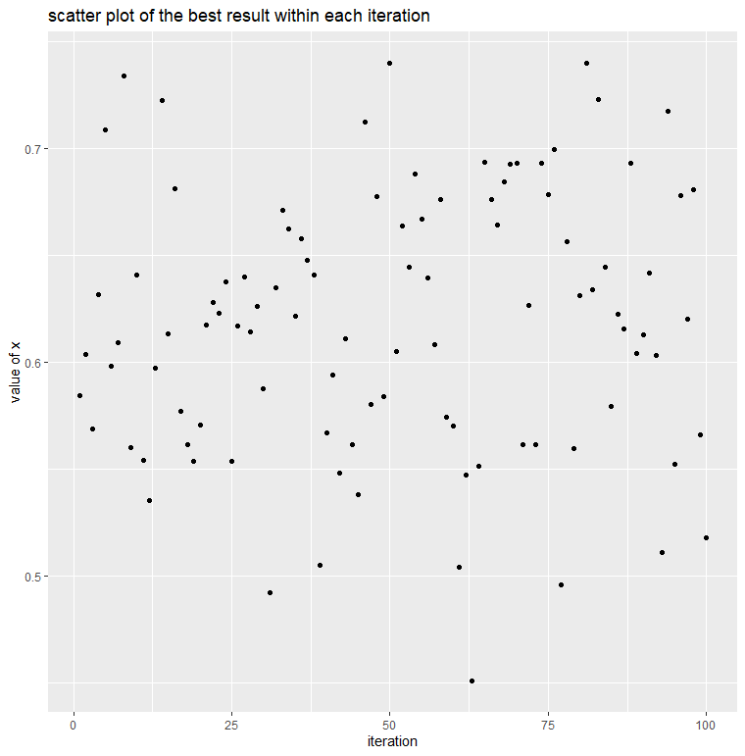Define the number of mutations by $mutation rate * total number of gene$. In this case, total number of gene equals to $0.2*1000=200$.
4. 200 random numbers will then be generated from $1 to total number of ge$ ne,
5. Marked the position of the gene by $random number/10=chromosome x, remainder =gene position$.
6. Replace the old value of the marked gene by adding or subtracting a random number from $U(0,1)$.

After updating the chromosome, evaluate the new generation and repeat the previous steps.

Figure 1

**3.6 Ending criteria**

If there is a dominant chromosome appear in long generations, the algorithm will be end with the dominant chromosome as the best solution.

The above process will be looped over 100 times and the result of each iteration in $f(x_{i})$ is shown in figure 1. $\max\left(f\left(x_{i}\right)\right)=0.74$

As we can see, only a few results generated from GA reached 0.7 or above, meaning that we may increase the number of populations in order to converge to the true answer better. However, due to the limitation of computation ability, this cannot be done. (refer to appendix)

**4. Quadrature method and a Monte Carlo method(Q3)**

**4.1 Quadrature method**

For the quadratic method, we find that the value of estimator using trapezoidal rule within the class of quadrature method.

For the algorithm:

1. *Initialization*

Set up a function for trapezoidal rule, input values including:

Variable “G” -- the function to approximate the value of integral. ($\int_{0}^{∞}{\frac{\left|\cos\left(x\right)\right|}{x}e^{-{\left(logx-3\right)}^{2}}dx}$)

Variable “Range” -- the range for partitioning intervals.

Variable “J” -- the number of partitions in the decided range. (10000 in this case)

In the function operation;

1. Find the length of each interval, by h= $\frac{difference of range}{number of intervals }$
2. Calculate the value of each interval by $θ_{i}=lower bound+h×(1,2,3…J)$
3. Then summing up the left and right Riemann sums by $estimation= \sum_{k=1}^{J}{(f\left(x_{k-1}\right)+}f(x_{k}))/2×h$

(implementing $\int_{a}^{b}{f(x)dx≈\sum_{k=1}^{N}{\frac{f\left(x_{k-1}\right)+f(x_{k})}{2}}}Δx$)

1. *Implementation*

Assume the upper bound is 1000, and apply the range from 0 to upper bound to the trapezoidal

function looping the function by 1000 times to check if the answer is in the range. By plotting graph we can see the true estimate have been found before 200 iterations. (refer to appendix 3.1)

So, we apply 200 to the upper bound to find the value of the integral. The return value is 1.127877.

**4.2 Monte Carlo Method**

For Monte Carlo method, we suppose $X\sim N(3,0.5)$. we can observe that

$$\int_{0}^{∞}{\frac{\left|\cos\left(x\right)\right|}{x}e^{-{\left(logx-3\right)}^{2}}dx=\sqrt{π}\int_{0}^{∞}{|cos⁡(x)|\frac{1}{x\frac{1}{\sqrt{2}}\sqrt{2π}}e^{-{\left(logx-3\right)}^{2}}dx={\sqrt{π}E}_{X}(|cosX|)}≈\frac{\sqrt{π}}{n}\sum_{i=1}^{n}{\left|\cos{x_{i}}\right|} }$$

where the second inequality holds as $\frac{1}{x\frac{1}{\sqrt{2}}\sqrt{2π}}e^{-{\left(logx-3\right)}^{2}}$ is the density function for $X\sim N(3,\sqrt{0.5})$.

For the implementation,

1) Monte Carlo estimator is given by .

2) Then generate X by (

3) Repeatedly apply the Monte Carlo estimator by 10000 trails.

As we can see the after 10000 trails the plot is converged, that means when the number of sample become lager the accuracy of the estimator will become higher. (refer to appendix 3.2 and 3.3)

The estimation was found by using 100000 samples, the value is approximately 1.1287333.

(by strong law of large number $\lim_{n→∞}{{\left(\frac{\sum_{i=1}^{n}{h(X_{i})}}{n}\right)}^{n}}=E_{f}(h\left(X\right))$ when we collect enough sample n the estimation is accurate enough)

**4.3 Comparison between Quadrature Method and Monte Carlo Method**

*a) Computational time*

the time required for quadrature method and Monte Carlo method is 0.07s and 0.112s respectively, in

this case quadrature method is obviously faster than Monte Carlo method. For quadrature rule, it is repeatedly calculating the partition by number of times, on the other hand, Monte Carlo method is repeatedly generating large number of samples from $N(3,0.5)$. Therefore, Monte Carlo method might take longer.

*b) Accuracy*

In quadrature method, the accuracy varies with the increase in the value of the upper bound, as mentioned shown in the plot, we can see the accuracy of trapezoidal rule becomes higher when the upper bound becomes larger. (eg for 500, the estimation is 1.1286999 while for 200 is 1.127877).

In Monte Carlo method, we can see the plot is converged which means when the sample size becomes larger, the accuracy of the estimator will also increase. (by strong law of large number)

c) Advantages for estimating

In quadrature method, known there are two major rules: Simpsons rule and trapezoidal rule. Both of them give deterministic result from the integration, therefore, the estimation should be closer to the truth also the variance of the estimation is smaller.

On the other hand, for Monte Carlo estimation, it is a randomness process, thus we need to interpret a distribution of how our samples are distributed. Although the variation between each iteration might be obvious compare to quadrature rule, Monte Carlo estimation can deal with any situation by applying accept-reject method.

**5. Monte Carlo method and MCMC method(Q4)**

**5.1 Monte Carlo Rejection Sampling**

Monte Carlo Rejection Sampling algorithm aims to draw independent samples from a given function. To estimate the correlation, we use this algorithm to draw samples from the given joint pdf.

**5.1.1 Algorithm**

Firstly, we find the correlation coefficient ($c$) of the joint pdf. Using R, we found that

$c = 4.78555$.

Then, using c, we can obtain the maximum density ($m$) of the joint pdf in range

$0≤x,y≤1$, which is $m = 8.617615$.

After getting the m, we can start to construct 100000 random samples of x and y in range $[0,1]$ and compute $p(x,y)$.

Then run the core of this algorithm:

Accept sample when $p\left(x,y\right)≥Unif\left(0,1\right) ×m$

Reject sample when $p\left(x,y\right)<Unif\left(0,1\right) ×m$

If the sample is accepted at iteration t, the t+1 iteration will begin consecutively.

While if the sample is rejected at iteration t, the rejected sample is discarded and the iteration will stay at t until a sample is accepted in t.

**5.1.2 Result**

After drawing 100000 samples, the estimated correlation is $-0.0625508$

**5.2 Hybrid Gibbs Sampler algorithm (Metropolis-Hastings within Gibbs sampler)**

Hybrid Gibbs Sampler is a combination of two Monte Carlo Markov Chain (MCMC) algorithms: Metropolis-Hastings (MH) and Gibbs sampler.

MH algorithm is fairly similar to the Rejection Sampling algorithm as they both share the idea of accepting or rejecting samples drawn from the proposal distribution. But unlike Rejection Sampling, MH algorithm would keep the rejected sample and the samples drawn are related to the previous samples, which construct a Markov Chain. Thus, this algorithm is called MCMC algorithm.

For Gibbs sampler, this algorithm is good in handling high dimensional distribution as it reduces it into p number of 1-dimension-full-conditional functions. Fundamentally, it is equivalent to the composition of p-MH algorithm with the acceptance rate (r) equals 1.

**5.2.1 Algorithm**

Firstly, let the given distribution $p(x,y)$ be our target distribution. Need to ensure the samples of x and y are both within the range [0,1].

Secondly, we choose initial values of x and y. We chose it randomly using *runif(1).*

And now we can compute the second sample and onwards. Below is the step of how hybrid Gibbs sampler can be implemented.

(Gibbs sampler procedure)

Generate $x^{(t+1)} \sim P\left(x | y^{\left(t\right)}\right)$ = $sin(πx)\sin^{20}(πx^{2})+sin(πy^{(t)})\sin^{20} (2π{y^{(t)}}^{2} )$

Generate $y^{\left(t+1\right)} \sim P(y|x^{\left(t+1\right)})$ = $sin(πx^{\left(t+1\right)})\sin^{20}(π{x^{\left(t+1\right)}}^{2})+sin(πy)\sin^{20} (2πy^{2} )$

As we can observe, those conditional functions do not correspond to a common distribution. We need to implement MH step.

(MH step)

We generate $x_{p}$ and $y_{p}$ from a proposal distribution. Here we take truncated $Normal$ as our proposal distribution $q(x,y)$:

$$x_{p}\sim truncated Normal\left(x_{new}, 0.5\right) \& y_{p}\sim truncated Normal\left(y_{new}, 0.5\right)$$

where

$0≤x_{p}$, $y_{p}≤1$

Note that:

$x_{new}$ and $y_{new}$ are random numbers generated from $U[0,1]$

The standard deviation of the normal sampling is manually decided.

Then calculate the acceptance rate **r**:

For $x$: r = $min\left\{\frac{P(x_{p}|y^{(t)}) }{P(x^{(t)}|y^{(t)})} \frac{q(x^{\left(t\right)}|x_{p})}{q(x_{p}|x^{\left(t\right)})} , 1\right\}$

For $y$: r = $min\left\{\frac{P(y_{p}|x^{(t+1)}) }{P(y^{(t)}|x^{(t+1)})} \frac{q(y^{\left(t\right)}|y_{p})}{q(y_{p}|y^{\left(t\right)})} , 1\right\}$

Accept $x^{(t+1)}$ and $y^{(t+1)}$ as $x_{p}$ and $y_{p}$ respectively with probability r. Otherwise, reject $x_{p}$ and $y_{p}$ and let $x^{(t+1)}$ and $y^{(t+1)}$ be $x^{(t)}$ and $y^{(t)}$ respectively.

**5.2.2 Result**

To ensure the sample are converged, we iterate the process 50000 times and set the burning period as 10000 (We discarded the first 10000 samples)

The estimated correlation between x and y is: $p(x,y) = -0.06094017$

**5.2.3 Comparison**

1. Computational Time: Rejection Sampling requires 24.35s, while hybrid Gibbs Sampler requires 4.20s.

2. Information required: Rejection Sampling needs to calculate correlation coefficient ($c$) and maximum density ($m$) of the joint pdf while hybrid Gibbs Sampler needs not.

3. Dependency: Samples drawn by Rejection Sampling is iid, while samples drawn by hybrid Gibbs Sampler is dependent.

**Appendix**

1. **Bisection method**

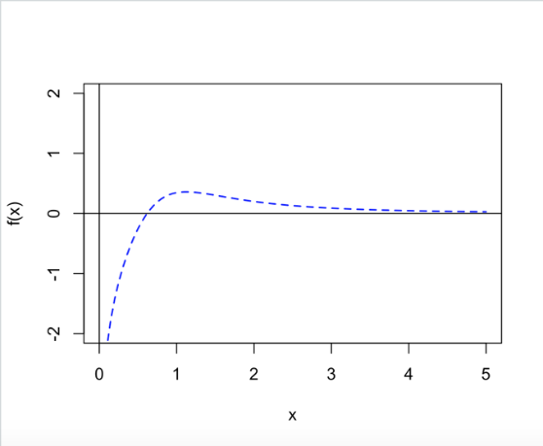

Plot1:x against f(x)

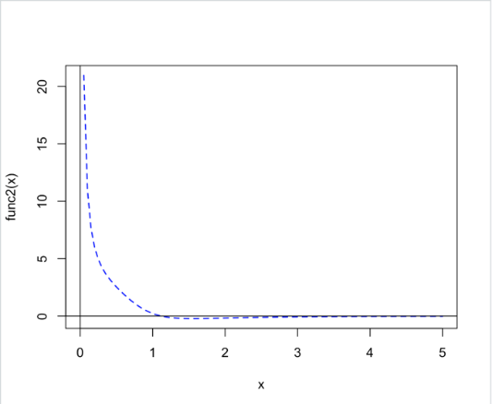Plot2:x against first derivative of f(x)

1. **Genetic Algorithm**

|  |  |  |  |  |  |
| --- | --- | --- | --- | --- | --- |
| Generation | 200 | 500 | 1000 | 2000 | 4000 |
| Time | 0.7413228 | 0.7445026 | 0.742463 | 0.7465313 | 0.7486217 |

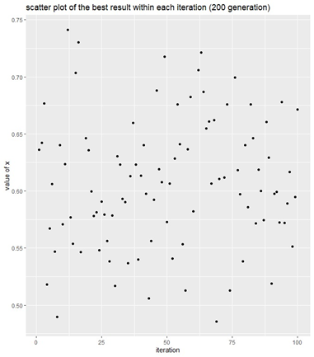

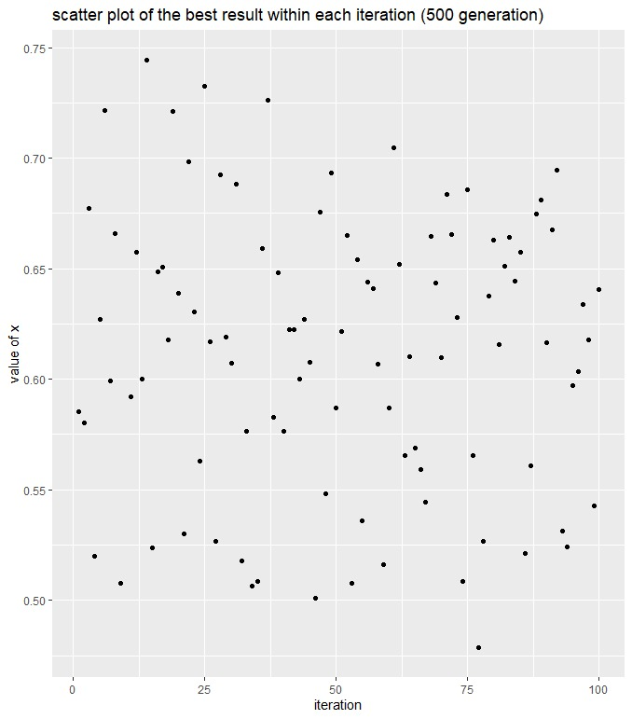

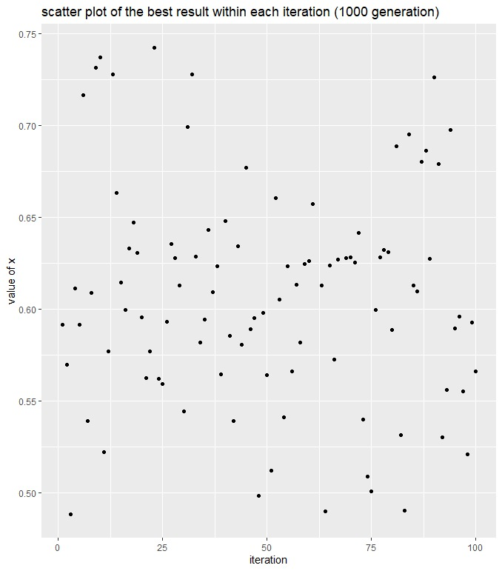

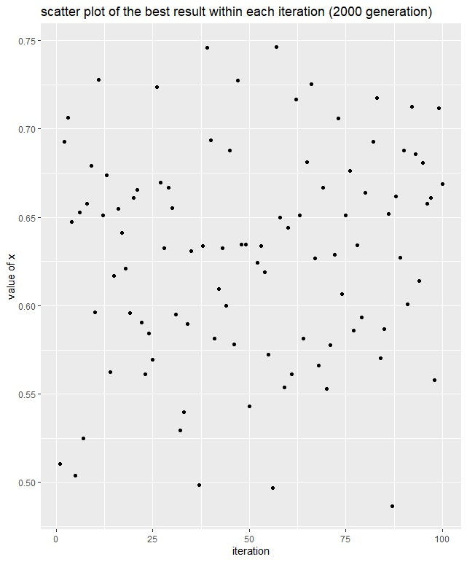

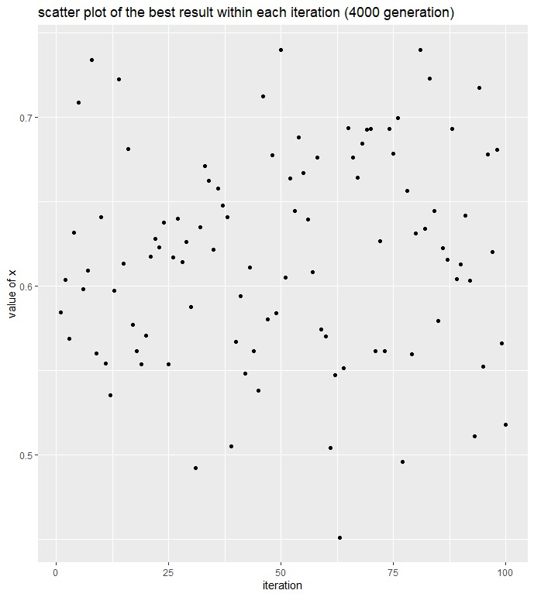

1. **Quadrature method**

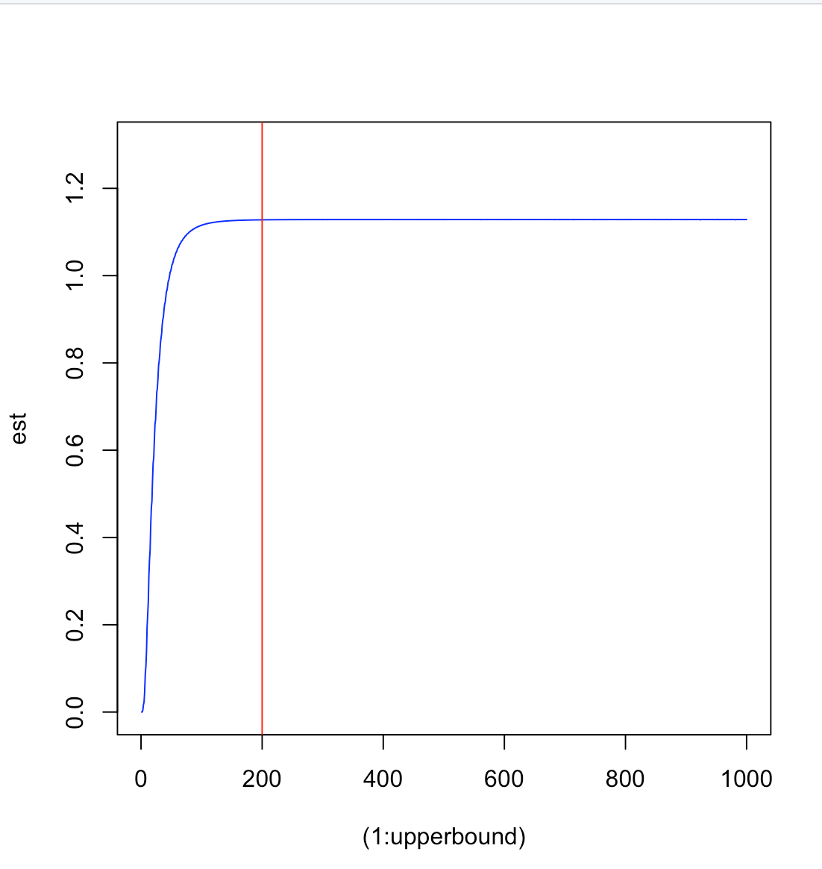

Figure 1

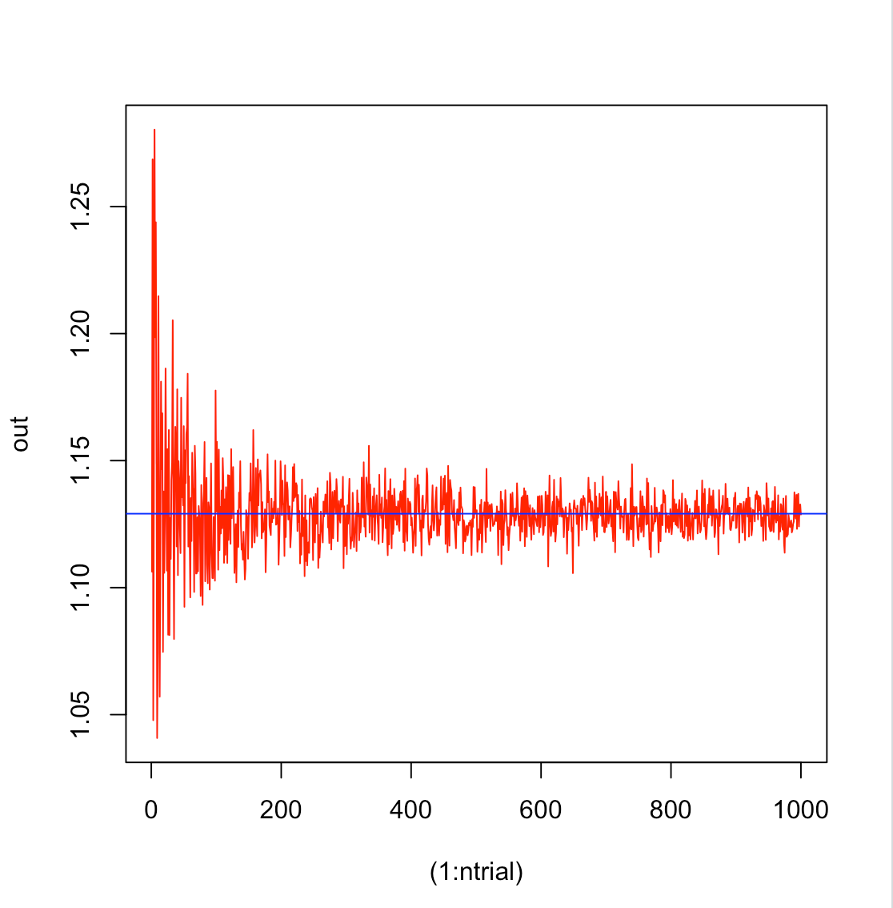 Figure 2

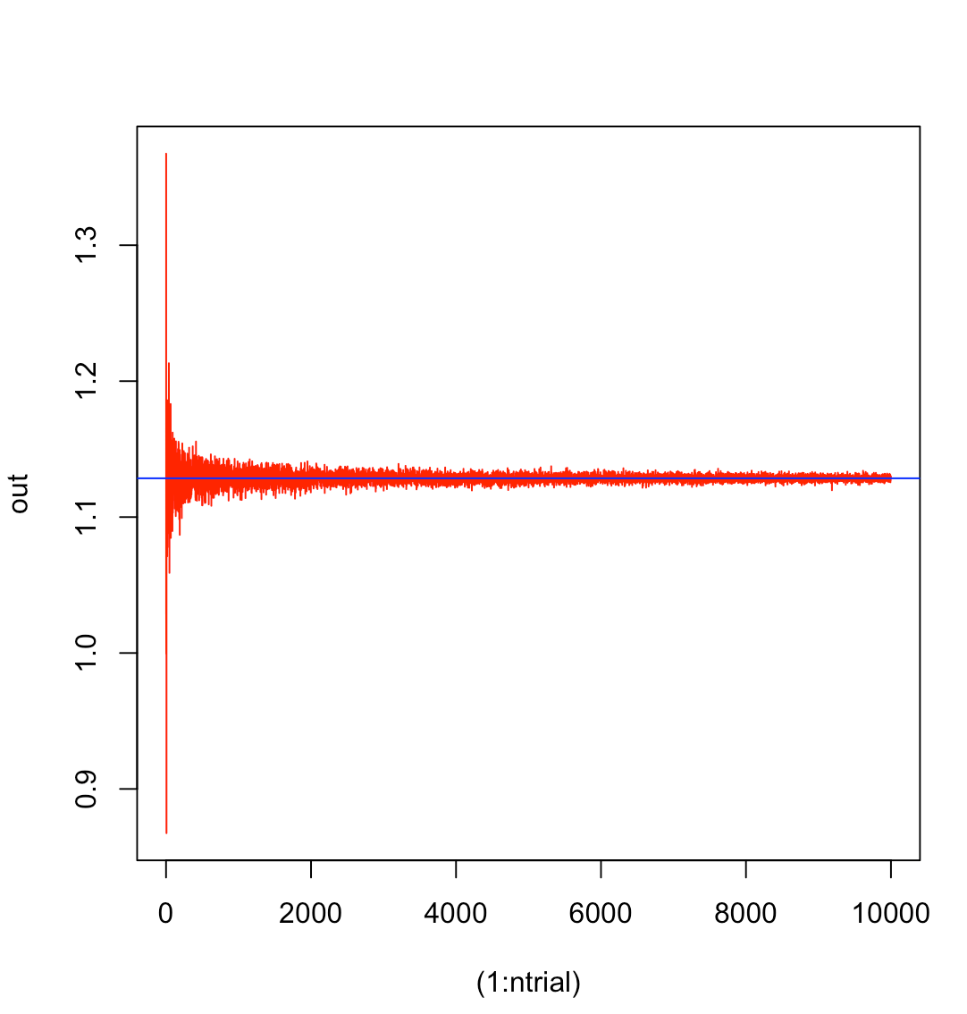 Figure 3

1. **MCMC**

|  |  |  |  |  |
| --- | --- | --- | --- | --- |
| Sample | 50 | 500 | 5000 | 50000 |
| Burn in | 30 | 300 | 3000 | 30000 |
| Time | 0.03 | 0.03 | 0.14 | 1.75 |

N=50

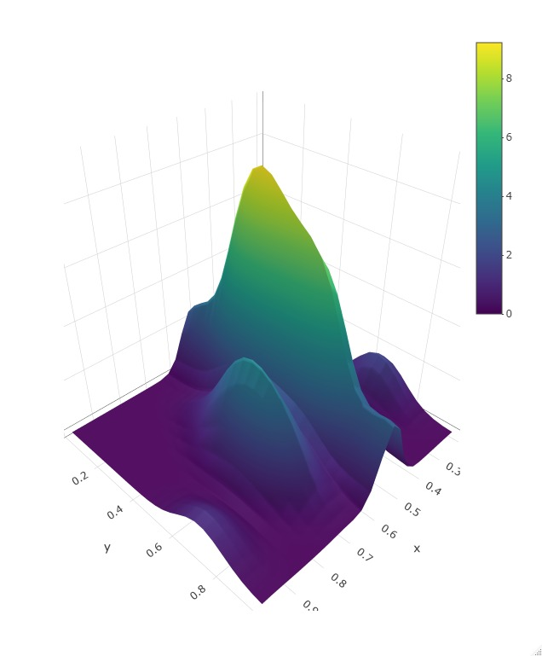

Figure 1

N=500

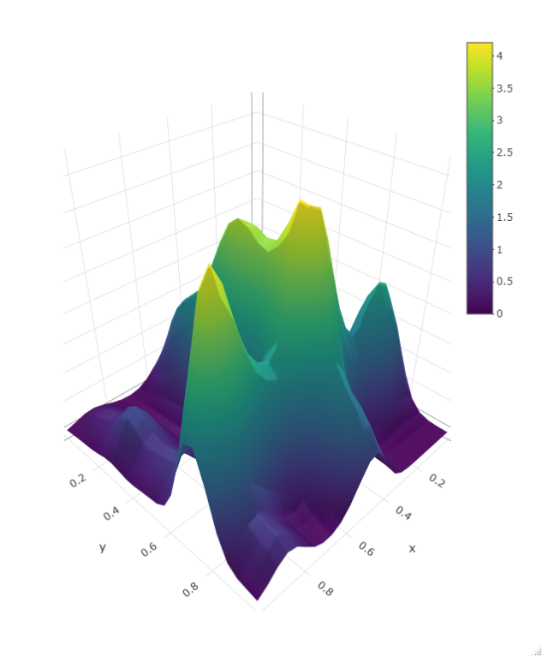

Figure 2

N=5000

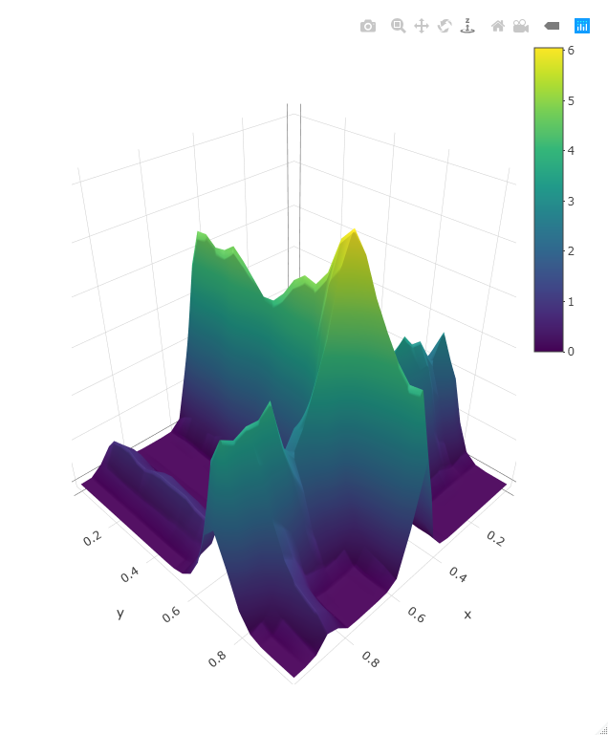

Figure 3

N=5000

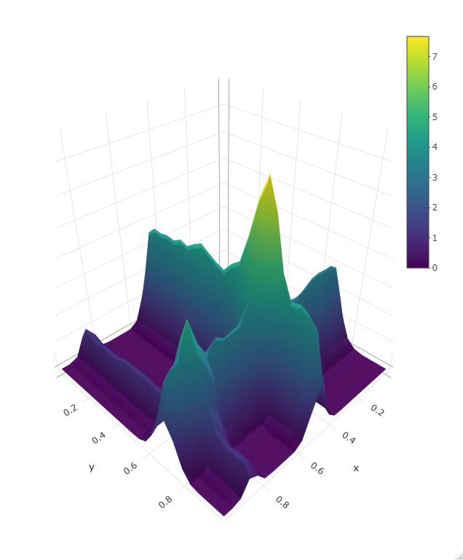

Figure 4

Sample from truncated normal

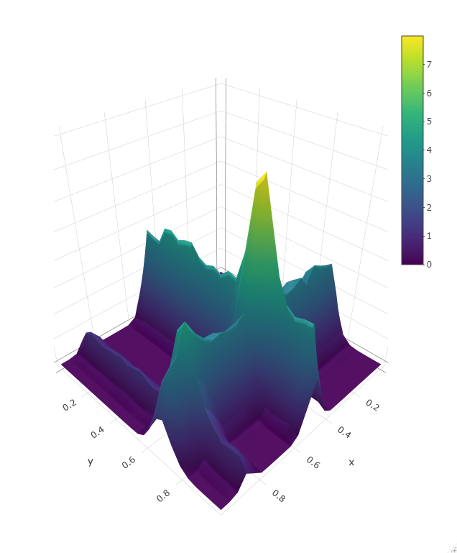

Figure 5

Sample from exp(3)

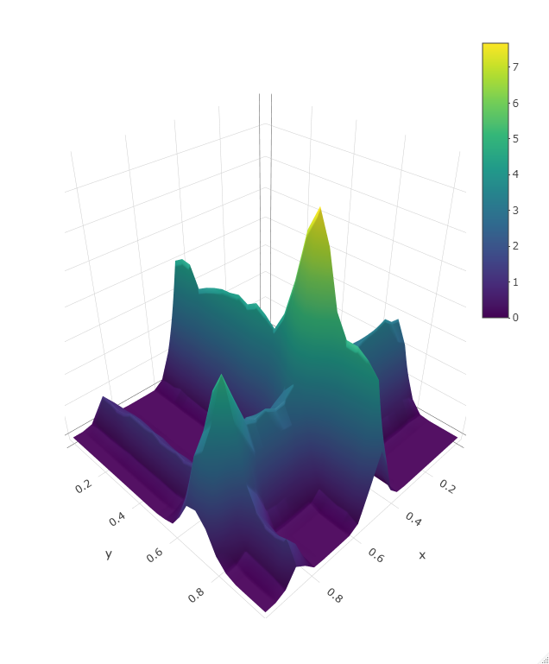

Figure 6

1. https://www.mathsisfun.com/algebra/intermediate-value-theorem.html
2. http://www.maths.dit.ie/~dmackey/lectures/Roots.pdf
3. https://web.mit.edu/10.001/Web/Course_Notes/NLAE/node6.html